Compensation of edge losses in silicon heterojunction solar cells by application of SEO light reflecting film
Andrea Pfreundt, Tero Tuohioja, Kari Rinko, Keimo Kalliosaari
Intelligent Control Systems Ltd., Laivakatu 3, 00150 Helsinki, Finland
Contact: keimo.kalliosaari@ics.fi

Introduction
Solar cell technology developments are advancing rapidly with high-efficiency solar cell technologies already leading the market. While the p-type PERC cell is currently the work horse of leading solar cell and module manufacturers, there is strong push with substantial investments into the emerging n-type technologies; tunnel-oxide passivated contacts (TOPCon) and heterojunction technology (HJT). [1] [2]
One advantage of HJT solar cells is the symmetrical cross section of the cells, with a stack of amorphous silicon layers on front and rear side. This reduces mechanical strain within the cell and enables the use of thinner wafer materials. The a-Si(i):H/a-Si(p/n):H passivation stacks for front/rear sides are typically deposited by plasma enhanced chemical vapor deposition on each side in turn as each side requires a different dopant of the top layer. On the solar cell edges this leaves only a residual a-Si:H layer on the edges which is much thinner than at the fully passivated surfaces and leads to higher recombination losses. [3] Simulations and experimental data confirm significant efficiency loss due to this reduction in passivation compared to a fully passivated surface. Even more pronounced, cut or cleaved cell edges, such as in half cells, third cells or shingles, do not have any dedicated passivation layer beyond the native silicon oxide that forms over time. [4] [5]
In addition to the reduced passivation on the edges, the transparent conductive layer (TCO, typically tin doped indium oxide, ITO) used to enable lateral transport beyond the limited conductivity of the doped a-Si:H layers, does not reach the (native) cell edges. This is necessary to avoid shunts across the cell edges and is typically achieved by masking the cell during TCO deposition, leaving the edge covered by a tapered off conductive layer. Charge carrier mobility is thus limited at the cell edges and generated charge carriers contribute less to the overall cell power compared to the rest of the cell. This is different for cut cell edges, where the TCO layer fully covers both front and rear surfaces up to the cut line.
Different re-passivation schemes have been proposed to alleviate cutting losses, especially for PERC cells [6] [7], but also for TOPCon and heterojunction technologies [8]. Since edge passivation requires an additional cell fabrication step, e.g. the deposition of a thin aluminum oxide layer, the economic feasibility of this step is questionable.
In this paper we introduce another method to compensate edge recombination losses on the module level, which is particularly interesting for heterojunction cells. By applying a light redirecting optics (Solar Energy Optics - SEO film) at the inside of the front glass, charge carrier generation can be moved away from the edge of the cell and into the center, where they can be more efficiently extracted.

Experimental
Silicon heterojunction M6 half cells with a 9 BB design were obtained from an industrial partner and connected individually or as 2-cell strings using 0.6 mm wide flat ribbons. For measurement of individual cells a jig was fabricated to achieve accurate and repeatable placement. Sixteen masks with different sized openings were used to cover increasing widths of the cell edges from 0 mm to 5 mm in 0.25 mm (up to 2.5 mm) and 0.5 mm steps (above 2.5 mm), shown in Figure 1 as a stack on top of each other. I-V curves of these cells were recorded in a A+A+A+ solar simulator at Endeas Oy, with a Xenon light source at a distance of 1147 mm from the cell surface. A forward and backward voltage sweep with capacitance compensation [9] was used to avoid any hysteresis effects in the measurement. Due to the finite distance of the light source and the necessary gap between shadow mask and cell surface, light can reach a small distance underneath the shadow masks. To account for this, an additionally illuminated distance of 0.25 mm was assumed in evaluation of the results, altering the effective shading distance of the masks.
SEO light redirecting film is a patented product of ICS Oy and produced in a cost-effective industrial roll-to-roll process. The UV protected optical polymer film is equipped with a clear adhesive layer.
Minimodules with industrial M6 heterojunction half cells were fabricated at Fraunhofer ISE using the following module stack: float glass/(SEO film)/POE/solar cell/POE/white backsheet. Strings of 2 solar cells were produced with a distance of 1.7 mm and cross connected into cell matrices with 2 mm distance between the strings. SEO film was applied to the inside of the front glass before lamination in a grid pattern matching the cell gaps. For the overlap modules the 3 mm and 4 mm wide SEO film was arranged to overlap all solar cell edges by 0.5 mm and 1 mm respectively; 0.15 mm more in between the cells, where the distance is 1.7 mm. A list of samples can be found in Table 1. Black masking tape was applied as an aperture to all modules, leaving a 4 mm margin around the cell edges, as shown in Figure 2. This ensures that all modules have the same illuminated area, which is the measure used for calculation of the module efficiency. I-V curve measurements of the minimodules were made in a A+A+A+ Pasan solar simulator with a 5 m tunnel length at Fraunhofer ISE.
Table 1: List of minimodules
Module configuration name | Cell matrix layout | Cell / String spacing | SEO film width between cells | SEO film overlap | Number of modules
HJT reference | 2 x 2 | 1.7 mm / 2 mm | - | - | 3
HJT 0.5 mm overl. (H1) | 2 x 2 | 1.7 mm / 2 mm | 3 mm | 0.5 mm | 3
HJT 1 mm overlap (H2) | 2 x 2 | 1.7 mm / 2 mm | 4 mm | 1 mm | 3

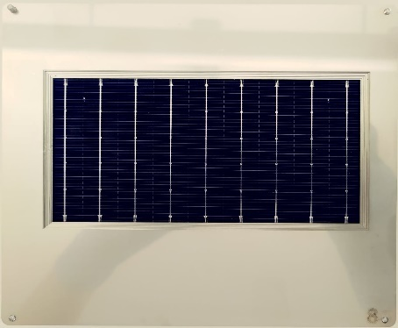  Figure 1: Shadow masks covering increasing portions of the solar cell edges from 0.25 mm up to 5 mm | 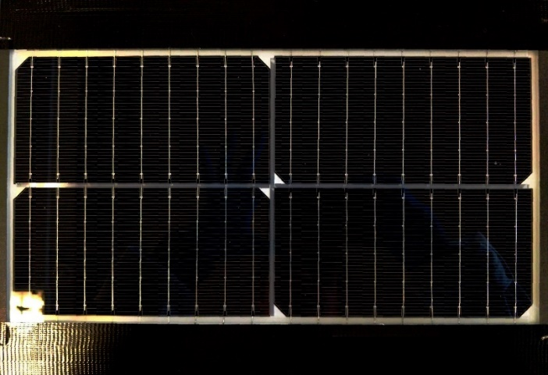  Figure 2: Minimodule with 4 heterojunction solar cells. Shown is a module with 3 mm SEO film in between the cells and 4 mm wide SEO film around the margins.

Results
Heterojunction cell measurements with shadow masks
Figure 3 shows the P_{MPP} and fill factor (FF) for three individually connected heterojunction cells, illuminated through shadow masks covering increasing widths of the cell edges. The covered distance is the same for all cell edges in each mask. For a solar cell with an ideal, homogeneous light response and no edge recombination or increased series resistances in the edge areas, we would expect a linear decrease of cell power with decreasing illuminated area. However, the measurement shows an initial deviation from the linear curve up to 1.25 mm shading distance from the edge, consistent with a reduced extraction efficiency at the cell edges. By covering the edge of the cell, fewer charge carriers are generated in an area where recombination is more likely. This effect is confirmed by the increase in FF which indicates that increasingly more of the generated charge is also extracted by the contacts.

Figure 3: Pmpp and FF of individual heterojunction cells with different sizes of shadow masks shading increasing widths of the cell edges on all four sides.
From the measured cell power, effective cell efficiencies were calculated for each slice of the edge region, shown in Figure 4 on the left. This metric regards each slice individually by comparing the two measurements with and without shading of that particular region. This method might disregard some transient effects but is suitable to illustrate the efficiency losses along the edges and their recovery potential. By combining the individual efficiencies per area, the full cell efficiency is reconstructed and shown in Figure 4 on the right. If 50% of the efficiency loss can be recovered by means of cell or module optimization, 0.20 % abs. cell efficiency can be gained (0.91 % rel.). As upper limit, we show that 0.40 % abs. or 1.83 % rel. can be gained if all the efficiency losses could be recovered. In the following section we are presenting a method to recover lost edge efficiency by redirecting incoming light from the edge region towards the center of the cell, where it can be more efficiently utilized.
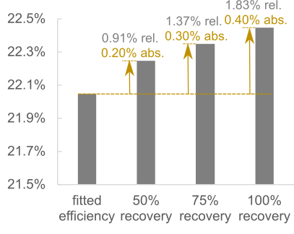
Figure 4: Effective cell efficiency for each slice of cell edge extracted from the masked I-V measurements of individual half cells. The black curve is a fitted average of all cells, the grey curves represent exemplary curves for different levels of recovered efficiency to illustrate the inherent potential. The right side shows the calculated total cell efficiency and absolute gain potential for each level of improvement.
Heterojunction minimodules
Minimodules with light redirecting Solar Energy Optics film (SEO film) were fabricated as described above and compared to reference modules in terms of I-V characteristics. Figure 5 shows the results for 3 modules in each group. Regarding the power output at MPP we achieve a 3.3 % and 3.8 % gain on average compared to the references with white backsheet and no SEO film. This gain is a combination of higher light harvesting from the inactive module areas (cell gaps and margins) and an increased effective cell efficiency from overlapping the less active cell edges. While the short circuit current increases in both modules with SEO film, the narrower film with smaller cell overlap shows a higher current compared to the wider film with a wider cell overlap. On the other hand, the power still increases with increasing SEO width even though less current is extracted at short circuit. This is attributed to a significant increase in FF, which can be explained by more efficient charge carrier extraction of the redirected light at higher bias voltage. Since all modules have the same area (defined by an aperture mask) and both SEO films cover the full inactive area between the cells, the increase in gain between the two configurations is a result of light distribution on the cell rather than additional light reaching the cell surface. The addition of SEO film in the modules result in efficiency gains of 0.66 % and 0.75 % abs. respectively.
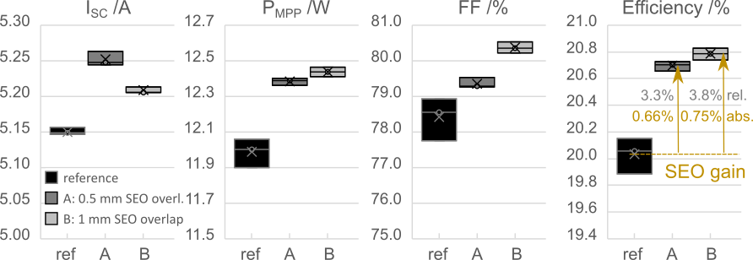
Figure 5: I-V parameters of 2 x 2 heterojunction half cell minimodules with and without SEO film applied between cells and on the margins. For modules with 3 mm SEO film the overlap between cell edge and SEO film is approx. 0.5 mm, for 4 mm SEO film it is approx. 1 mm.
Full size module simulation
The commercial optical simulation software LightTools was used for construction of different PV module models. The detailed module geometry, internal construction of cells and interconnections and related optical properties of bulk and surfaces can be accurately modelled. This includes the precise modelling of the SEO film and all its components.
A model comprising four M6 sized half cells was constructed, matching the minimodule layouts presented in the previous chapter. Even though the efficiency drop at cell edges is related to semiconductor phenomena, and as such, out of the scope of the ray tracing model, it is possible to optically model the same effect by reducing the light absorption efficiency of a cell close to its edges.
Without any adjustment of the edge efficiency, the simulation results in 2.6 % and 2.4 % power gains for the two SEO overlap layouts respectively. This result is consistent with previous experimental data obtained from modules with other types or solar cells (data not shown). The measurement results of the 2x2 minimodules with two different lengths of overlap were utilized to calibrate the light absorption distribution profile of the solar cell edges in the model to return the power gains of 3.3 % for 0.5 mm SEO overlap, and 3.8 % for the 1 mm SEO overlap. The minimized merit function was the delta between the measured gain values, and the simulated gain values in both SEO overlap cases. The successful calibration yielded an edge absorption profile following a quadratic function. The simulation supports the proposed benefit with SEO film in modules with HJT cells, quantifying the effect to 0.7 % and 1.4 % added power gain for the two overlap cases respectively.
With the calibrated model the simulation of full size HJT modules can be performed. Typically, by increasing the module size, the SEO film to silicon ratio decreases, and hence slightly lower gains are expected in a full-size module compared to the gains obtained from minimodules. In Table 2 the simulation results of four different module layouts are presented, 120 and 144 half cells with two different SEO overlaps. Both module layouts were simulated with either 2 mm cell and string spacing, or 3 mm cell and string spacing to show the effect of increased cell gaps on the gain. The first part of the table shows modules with a white backsheet, the second part shows modules with a transparent backsheet. Results indicate a clear improvement on module powers, with efficiency gains between 2.2 % for a white backsheet module and 2 mm cell / string gaps up to 4.6 % for a transparent backsheet module and 3 mm cell/ string gaps, corresponding to a boost from 2 to 4 module power classes.
Table 2: SEO gain estimation based on raytracing simulation of full size HJT modules, calibrated using measurement data from minimodules. Modules with a power of 400 W_{p} / 480 W_{p} for 120 and 144 cells with white backsheet were used as basis. Results are shown for utilization of a white or a transparent backsheet covering the module rear side. References for the gain calculation are same size modules with 2 mm cell and string gap and the same backsheet (marked in bold). The simulation considers only front side irradiance in laboratory lighting conditions without any albedo.
 |  |  |  | 120-cell – white bs |  |  | 144-cell – white bs
Cell / string gap | SEO overlap width |  | SEO gain |  | Module P_{MPP} | Module η | SEO gain | Module P_{MPP} | Module η
2 mm | no SEO |  | - |  | 400.0 W_{p} | 22.41 % | - | 480.0 W_{p} | 22.49 %
 | 0.5 mm |  | 2.2 % |  | 408.8 W_{p} | 22.91 % | 2.2 % | 490.4 W_{p} | 22.98 %
 | 1 mm |  | 2.6 % |  | 410.3 W_{p} | 22.99 % | 2.5 % | 492.2 W_{p} | 23.06 %
3 mm | 0.5 mm |  | 3.2 % |  | 412.7 W_{p} | 22.76 % | 3.1 % | 495.1 W_{p} | 22.83 %
 | 1 mm |  | 3.5 % |  | 414.0 W_{p} | 22.84 % | 3.5 % | 496.7 W_{p} | 22.91 %

 |  |  |  | 120-cell – transparent bs |  |  | 144-cell – transparent bs
Cell / string gap | SEO overlap width |  | SEO gain |  | Module P_{MPP} | Module η | SEO gain | Module P_{MPP} | Module η
2 mm | no SEO |  | - |  | 393.8 W_{p} | 22.07% | - | 472.6 W_{p} | 22.14%
 | 0.5 mm |  | 3.3 % |  | 406.9 W_{p} | 22.80% | 3.2 % | 487.9 W_{p} | 22.86%
 | 1 mm |  | 3.8 % |  | 408.6 W_{p} | 22.90% | 3.7 % | 489.9 W_{p} | 22.96%
3 mm | 0.5 mm |  | 4.3 % |  | 410.6 W_{p} | 22.65% | 4.0 % | 491.7 W_{p} | 22.68%
 | 1 mm |  | 4.6 % |  | 412.0 W_{p} | 22.73% | 4.4 % | 493.4 W_{p} | 22.76%

Conclusion
Our experimental data from individual industrial heterojunction solar cells confirm efficiency challenges related to the cell edges. Towards the edge of the cell, charge carriers can be less effectively extracted, leading to an overall loss in cell efficiency. We could show that by applying SEO film inside the PV module and overlapping the cell edge, light is redirected into more efficient areas of the cells and thus improves the effective cell efficiency. Besides compensating edge losses of the solar cells, SEO film also boosts module efficiency by utilizing light from otherwise inactive module areas in between the cells and on the module margin. Detailed optical simulations, validated by experimental data, show the potential for full size heterojunction modules. Power gains of up to 2.6% are possible for narrow (2 mm) cell gaps in comparison to a module with a white backsheet. In comparison to glass-glass modules or compared to modules without cell gaps the expected power gain is even higher. PV module optimization with SEO film is a cost-effective improvement of module power and efficiency that can be applied to residential and commercial module sizes with added Wp costs well below the regular module cost.

References

[1] | G. M. Wilson, M. Al-Jassim, W. K. Metzger, S. W. Glunz, P. Verlinden, G. Xiong, L. M. Mansfield, B. J. Stanbery, K. Zhu, Y. Yan, J. J. Berry, A. J. Ptak, F. Dimroth, B. M. Kayes, A. C. Tamboli, R. Peibst11 and K, "The 2020 photovoltaic technologies roadmap," Journal of Physics D: Applied Physics, vol. 53, p. 493001, 2020.
[2] | F. Colville, "TOPCon-production and Heterojunction-capex defining PV cell technology trends for 2023-2025," Sept 2022. [Online]. Available: https://www.pv-tech.org/topcon-production-and-heterojunction-capex-defining-pv-cell-technology-trends-for-2023-2025/.
[3] | V. Giglia, J. Veirman, R. Varache, B. Portaluppi, S. Harrison and E. Fourmond, "Influence of Edge Recombinations on the Performance of Half-, Shingled- and Full Silicon Heterojunction Solar Cells," 37th European Photovoltaic Solar Energy Conference and Exhibition, pp. 282-285, 2020.
[4] | V. Giglia, R. Varache, J. Veirman and E. Fourmond, "Influence of cell edges on the performance of silicon heterojunction solar cells," Solar Energy Materials and Solar Cells, p. 111605, 2022.
[5] | H. Stolzenburg, A. Fell, F. Schindler, W. Kwapil, A. Richter, P. Baliozian and M. C. Schubert, "Edge recombination analysis of silicon solar cells using photoluminescence measurements," 9th International Conference on Crystalline Silicon Photovoltaics, p. 020017, 2019.
[6] | P. Baliozian, M. Al-Akash, E. Lohmüller, A. Richter, T. Fellmeth, A. Münzer, N. Wöhrle, P. Saint-Cast, H. Stolzenburg, A. Spribille and R. Preu, "Postmetallization “Passivated Edge Technology” for Separated Silicon Solar Cells," IEEE Journal of Photovoltaics, vol. 10, no. 2, pp. 390-397, 2020.
[7] | N. Wöhrle, T. Fellmeth, E. Lohmüller, P. Baliozian, A. Fell and R. Preu, "THE SPEER SOLAR CELL – SIMULATION STUDY OF SHINGLED BIFACIAL PERC-TECHNOLOGY-BASED STRIPE CELLS," 33rd European PV Solar Energy Conference and Exhibition, pp. 844 - 848, 2017.
[8] | W. Li, X. Wang, J. Guo, X. Zhang, B. Chen, J. Chen, Q. Gao, X. Yang, F. Li, J. Wang, D. Song, S. Wang, H. Li and J. Chen, "Compensating Cutting Losses by Passivation Solution for Industry Upgradation of TOPCon and SHJ Solar Cells," Advanced Energy Sustainability Research, p. 2200154, 2022.
[9] | H. Vahlman, J. Lipping, J. Hyvärinen, A. Tolvanen and S. Hyvärinen, "Capacitive effects in high-efficiency solar cells during I-V curve measurement: considerations of error of correction and extraction of minority carrier lifetime," 35th European Photovoltaic Solar Energy Conference and Exhibition, pp. 254 - 261, 2018.

